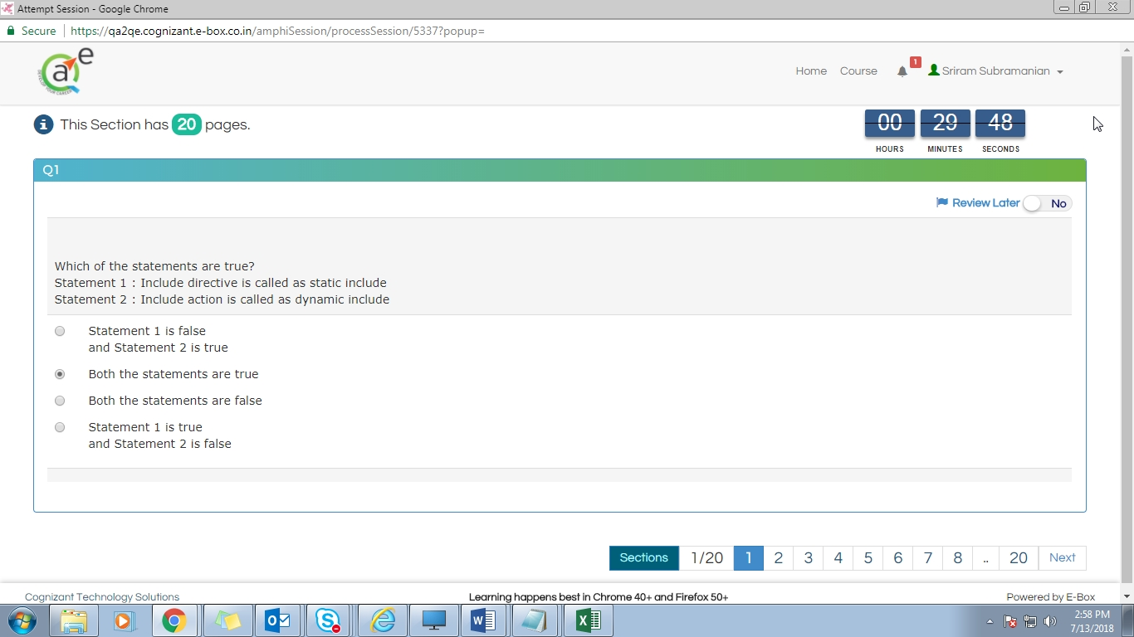Screenshot 2:7/13/2018 14:58:21.404

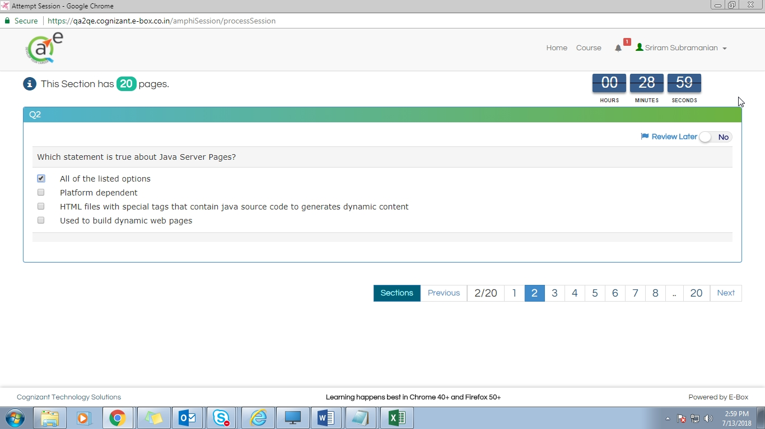Screenshot 3:7/13/2018 14:59:10.681

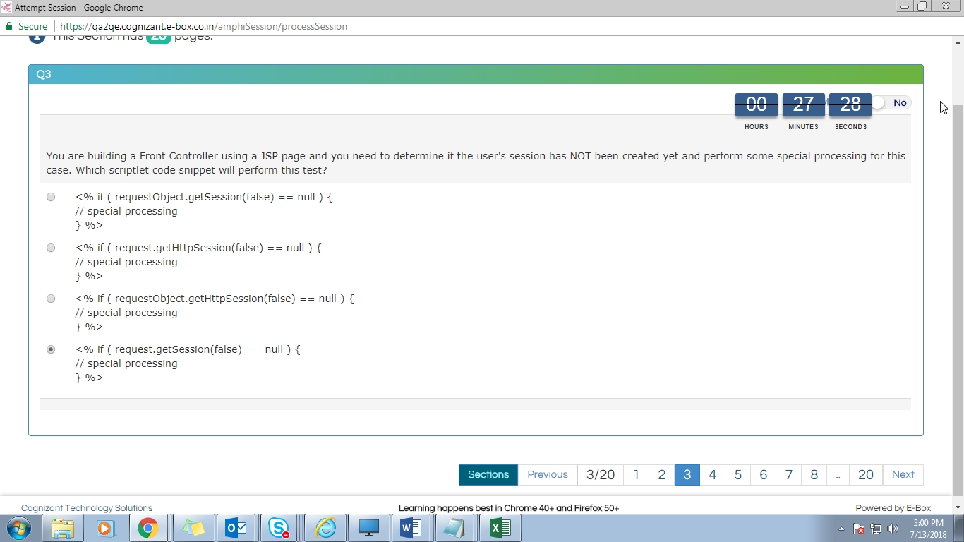Screenshot 4:7/13/2018 15:00:41.751

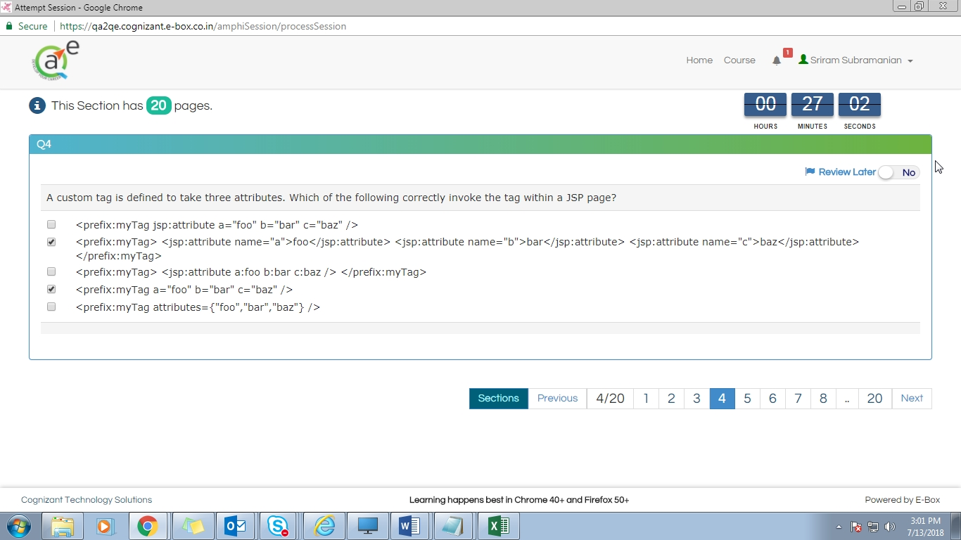Screenshot 5:7/13/2018 15:01:08.273

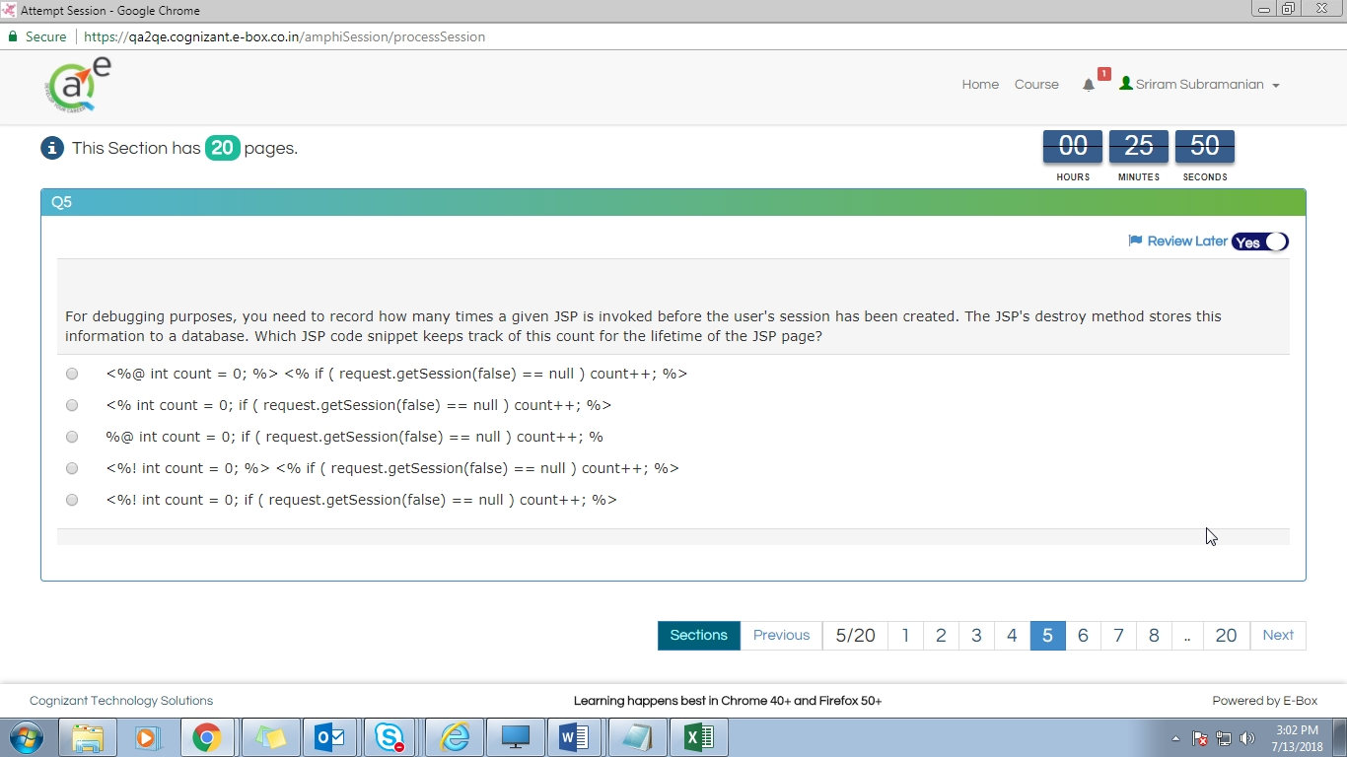Screenshot 6:7/13/2018 15:02:19.224

Ans- 4

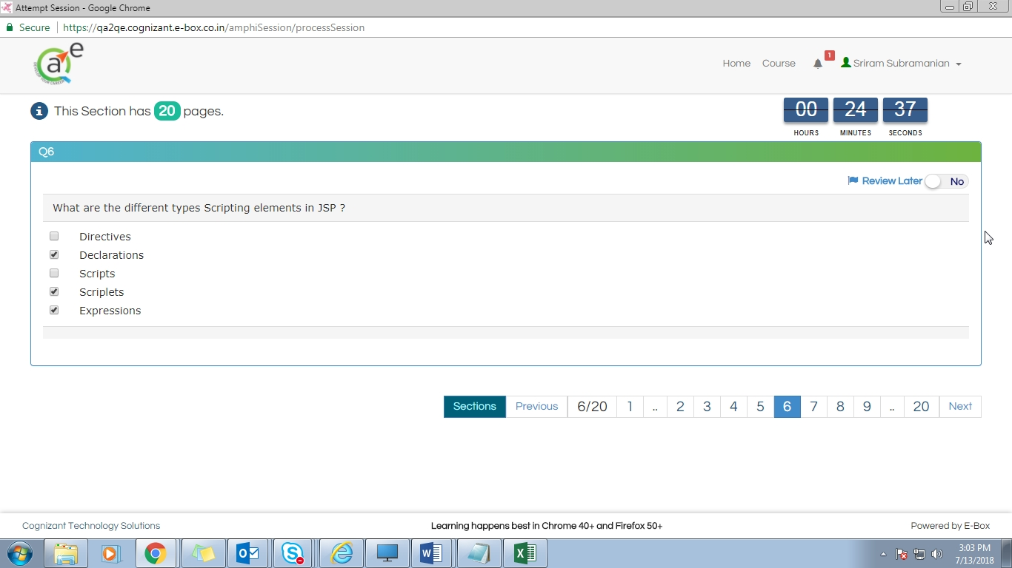Screenshot 7:7/13/2018 15:03:32.626

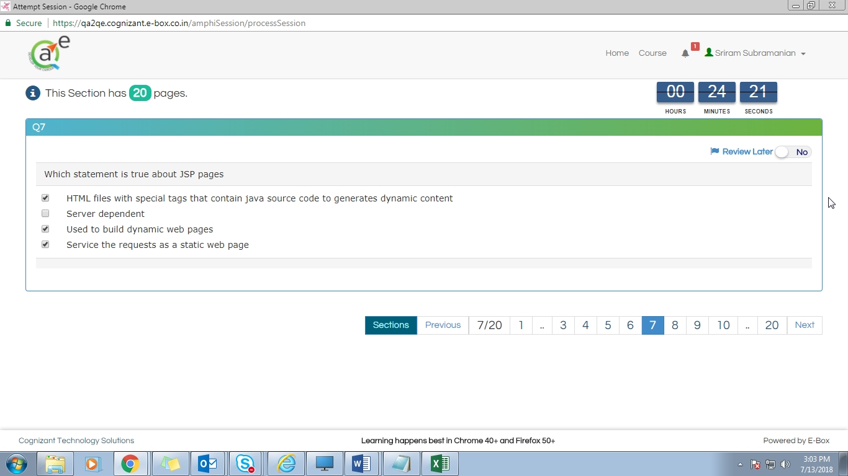Screenshot 8:7/13/2018 15:03:48.989

Ans-1,2,3

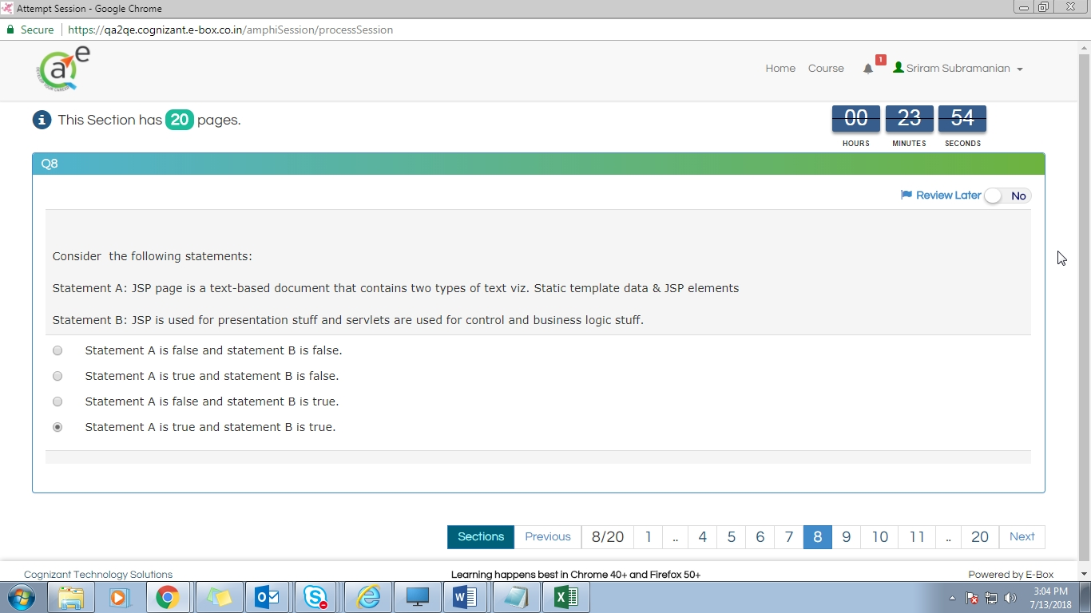Screenshot 9:7/13/2018 15:04:17.066

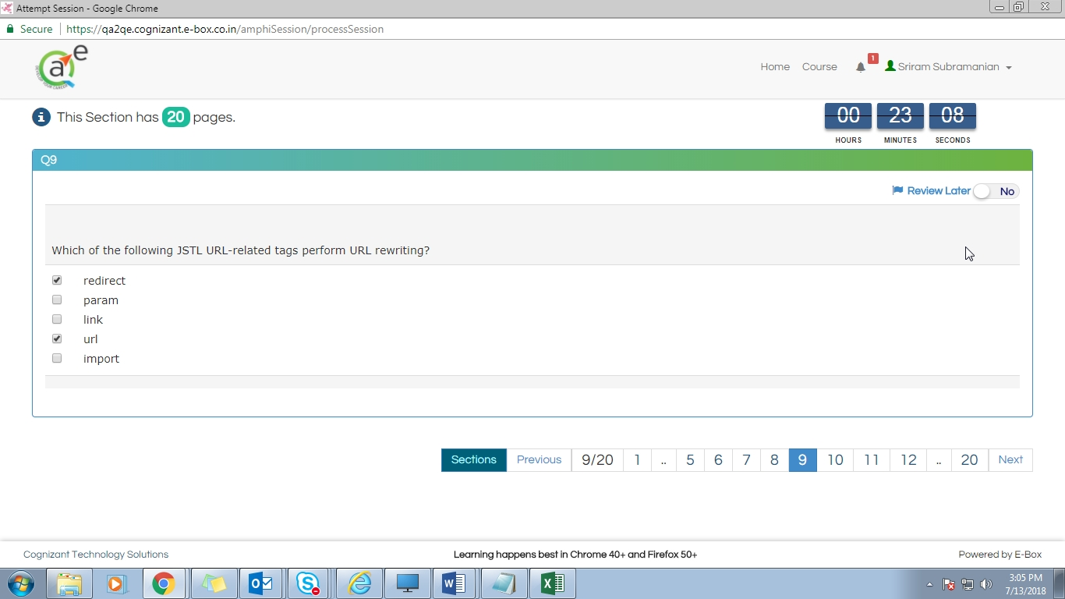Screenshot 10:7/13/2018 15:05:03.205

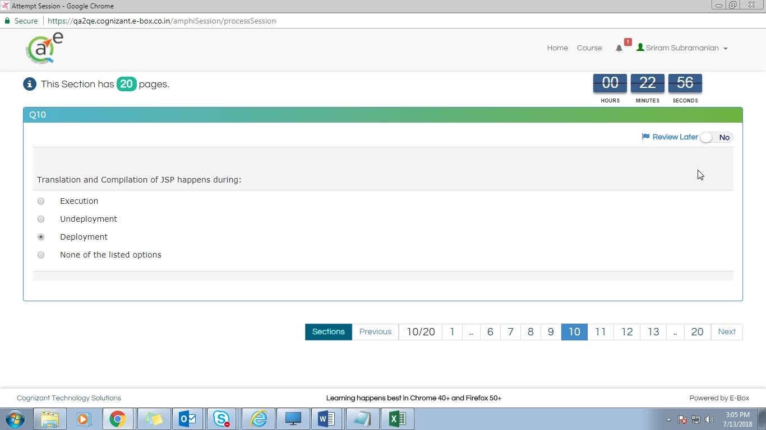Screenshot 11:7/13/2018 15:05:14.294

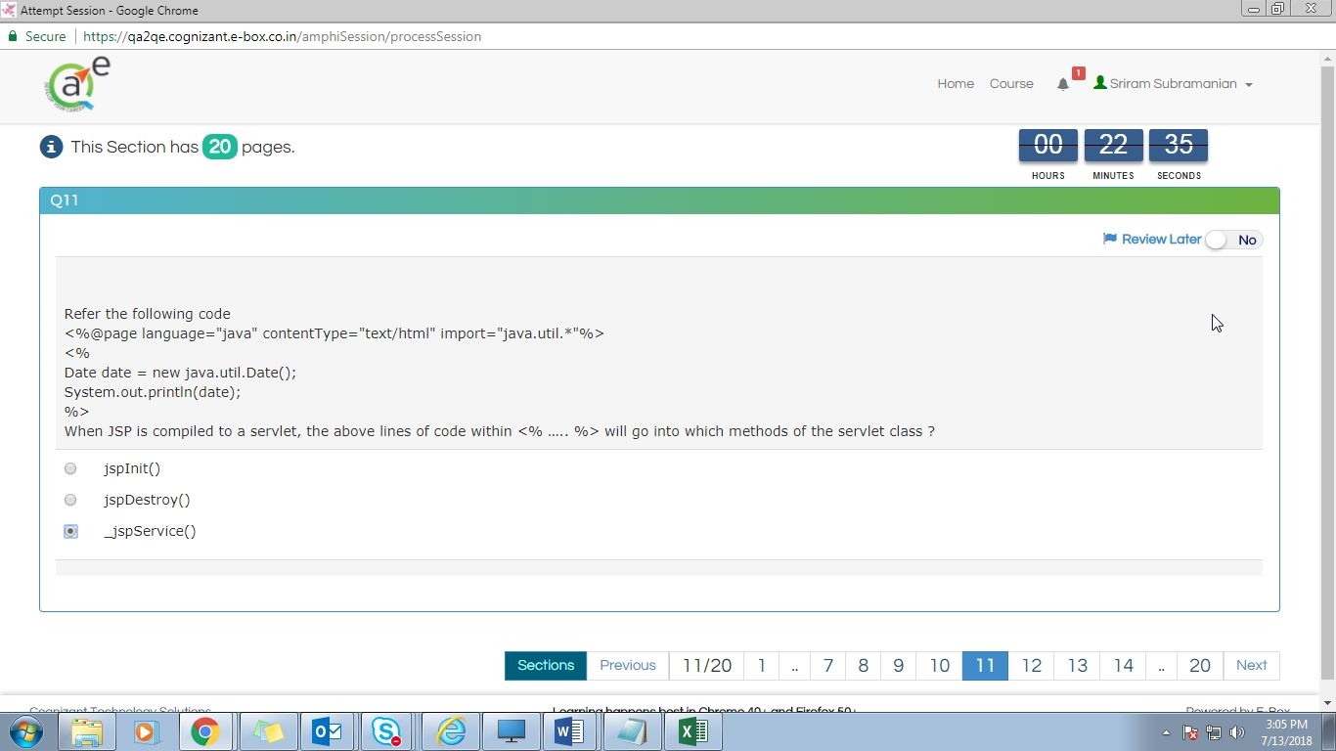Screenshot 12:7/13/2018 15:05:34.574

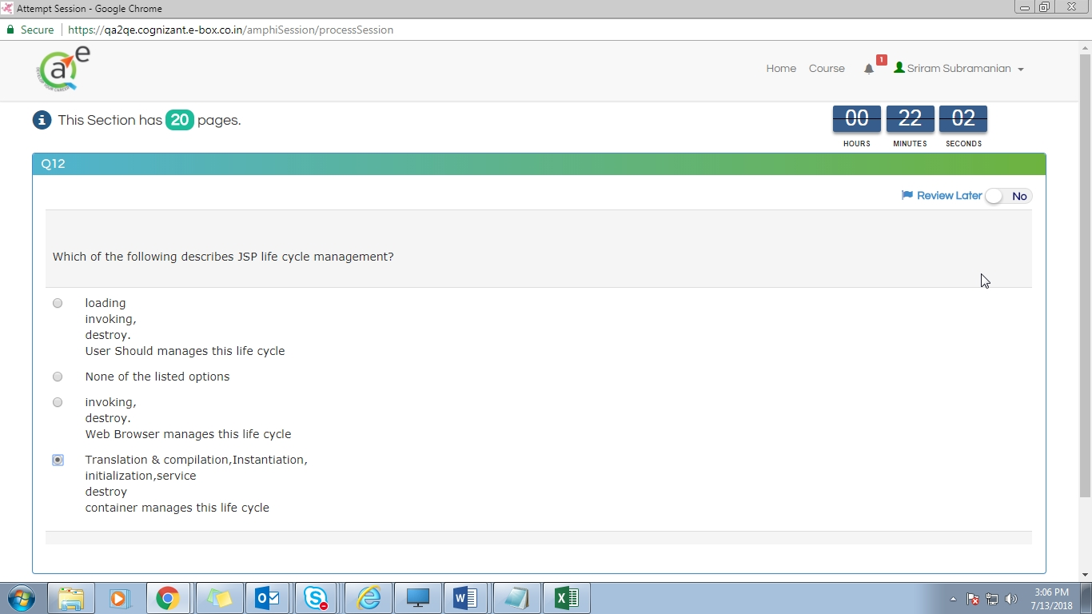Screenshot 13:7/13/2018 15:06:08.824

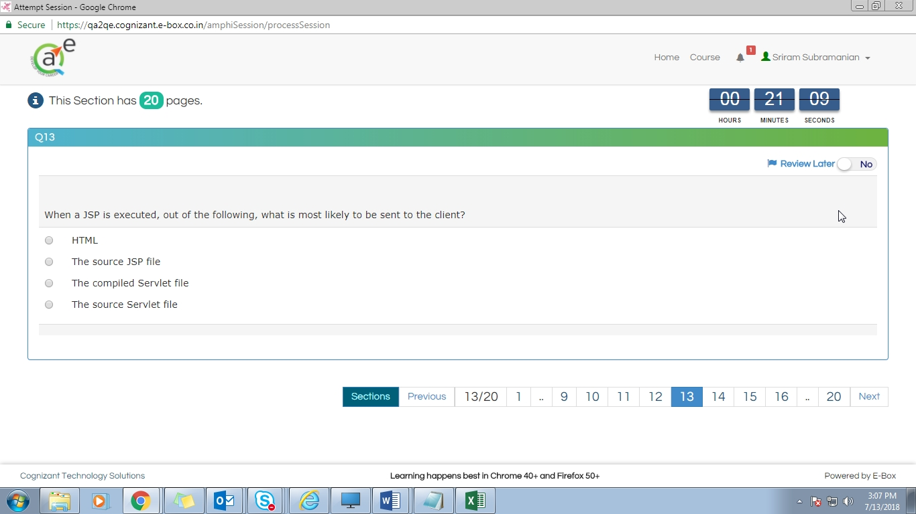Screenshot 14:7/13/2018 15:07:01.566

Ans-1

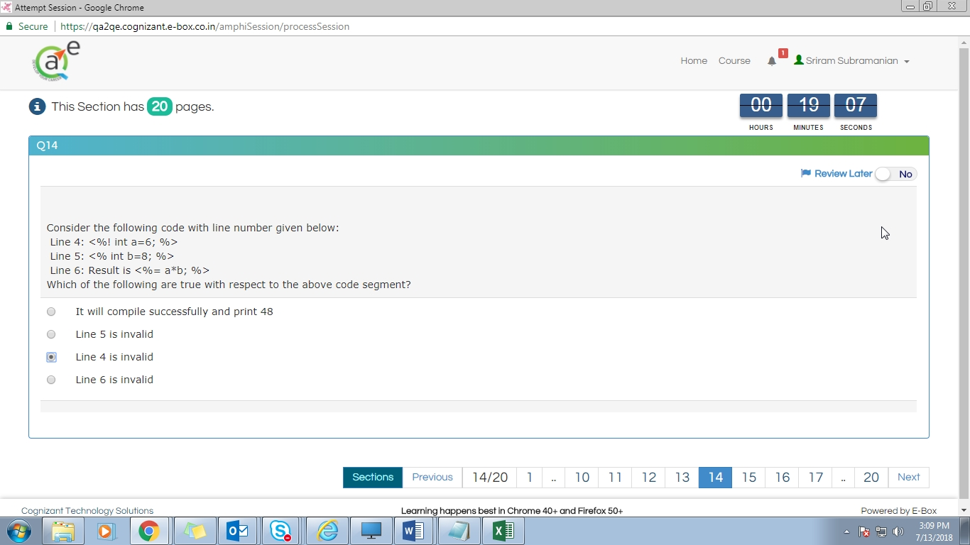Screenshot 15:7/13/2018 15:09:03.081

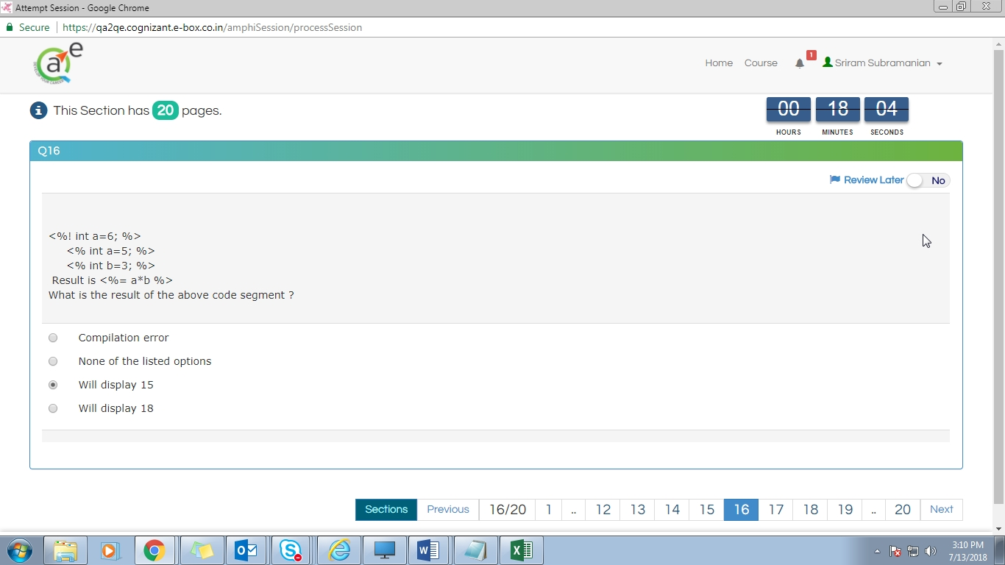Screenshot 18:7/13/2018 15:10:05.738

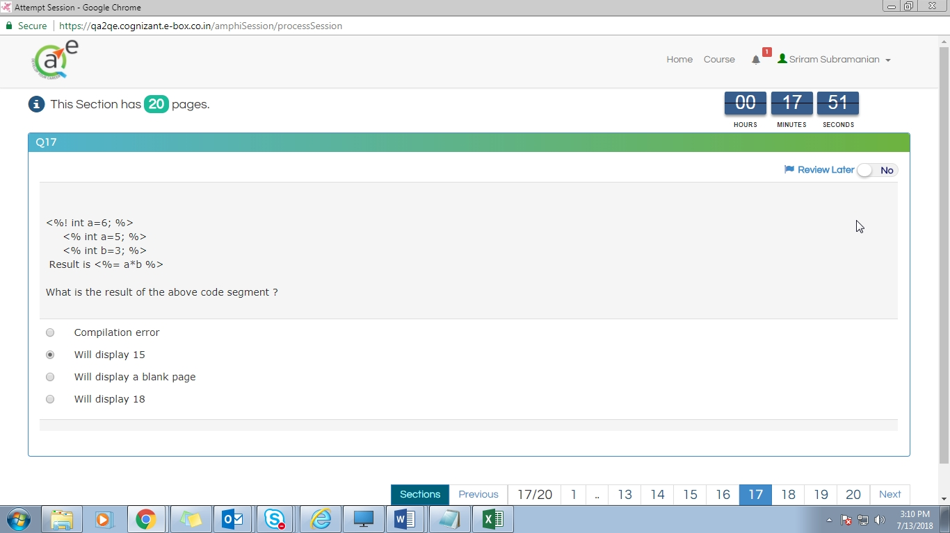Screenshot 19:7/13/2018 15:10:19.010

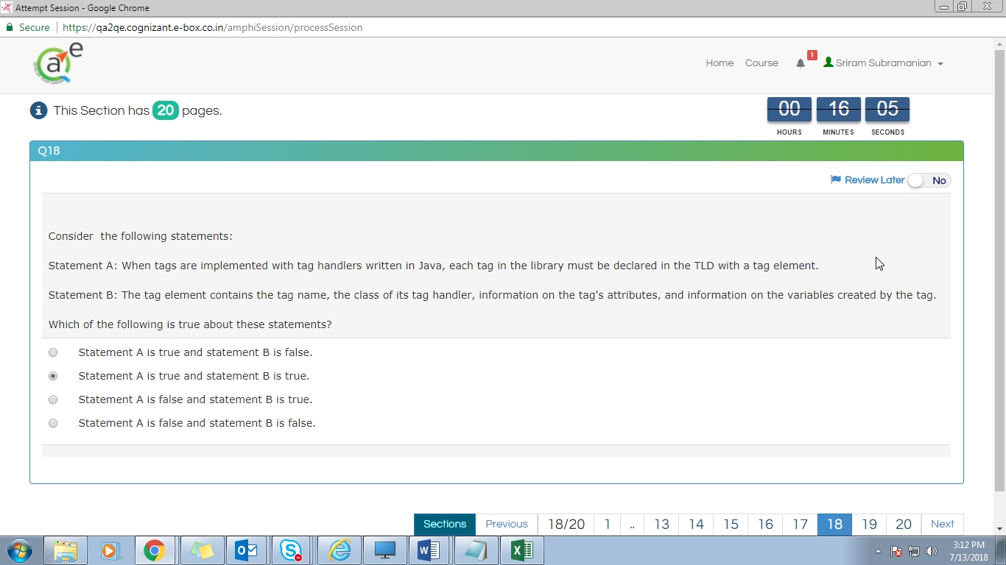Screenshot 22:7/13/2018 15:12:05.475

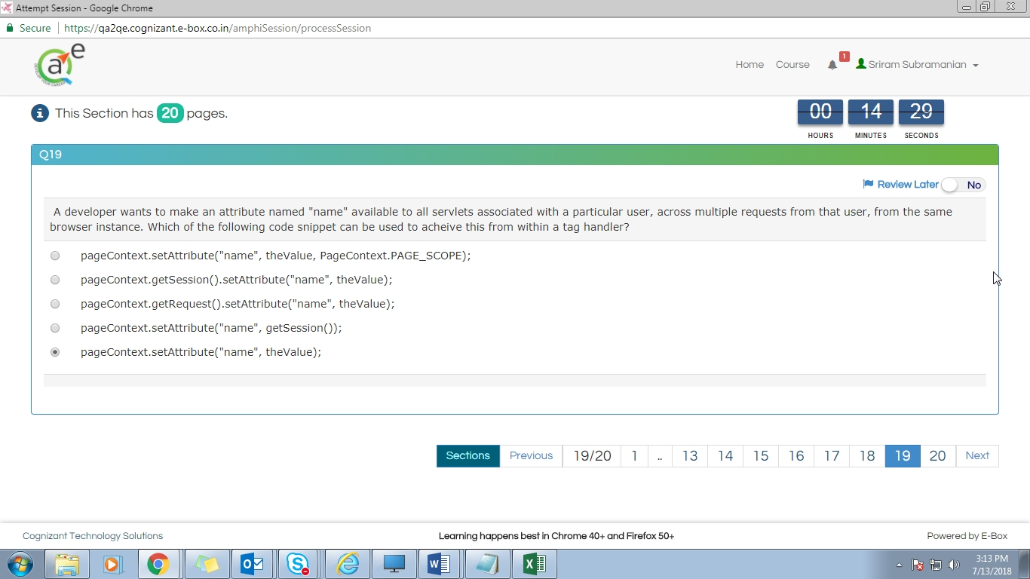Screenshot 23:7/13/2018 15:13:42.505

Ans-1

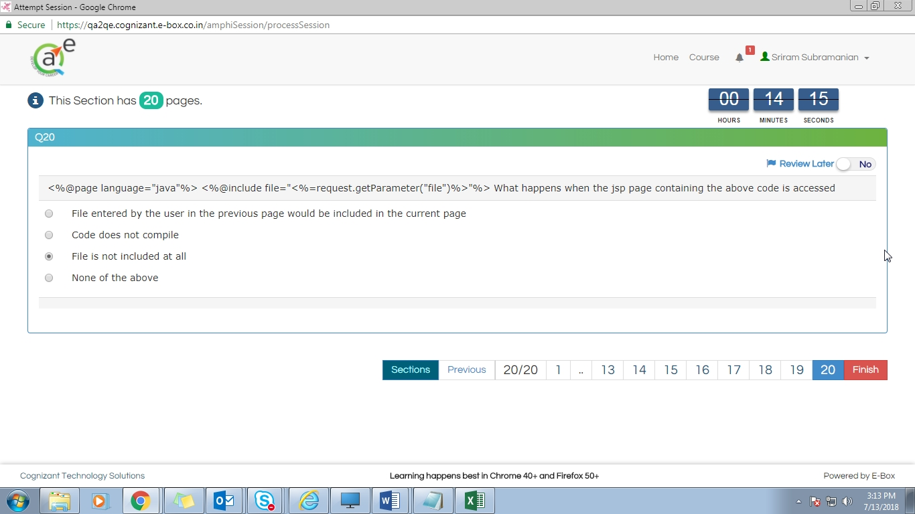Screenshot 24:7/13/2018 15:13:55.548

Ans-2

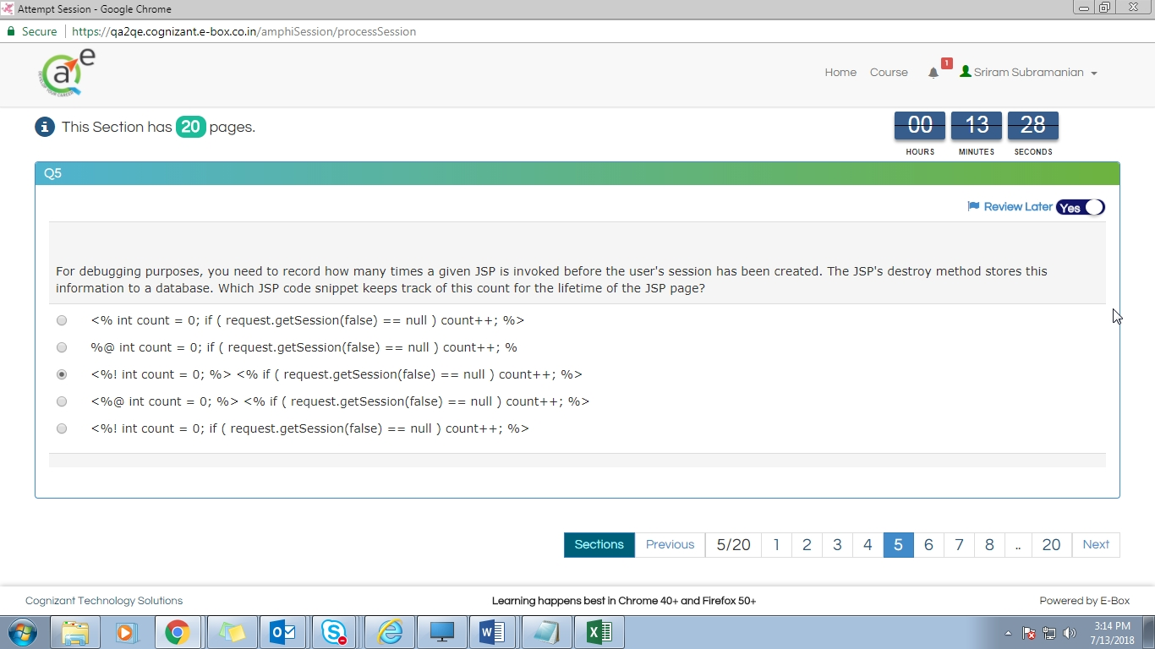Screenshot 25:7/13/2018 15:14:41.532

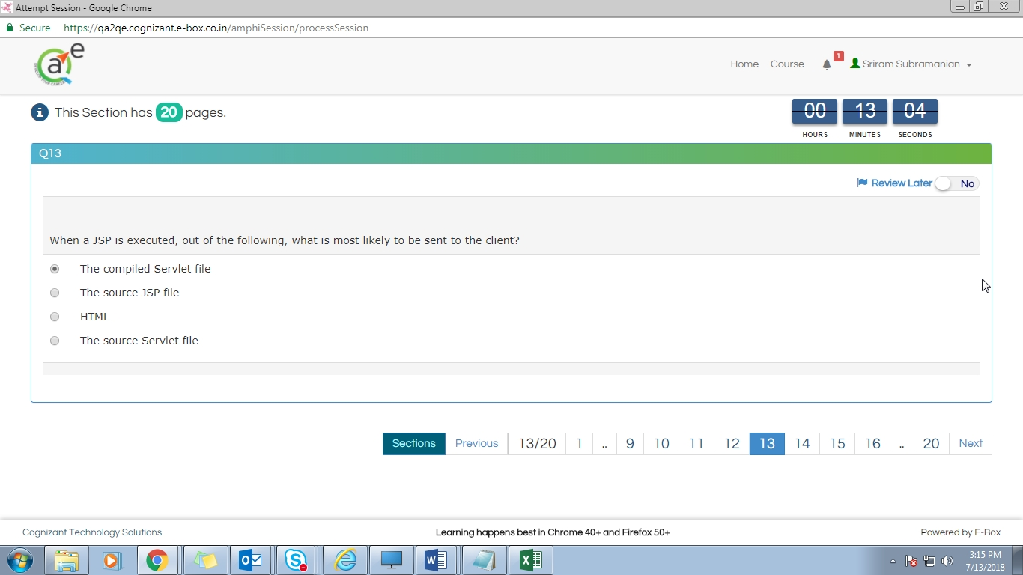Screenshot 26:7/13/2018 15:15:06.145

Ans-3

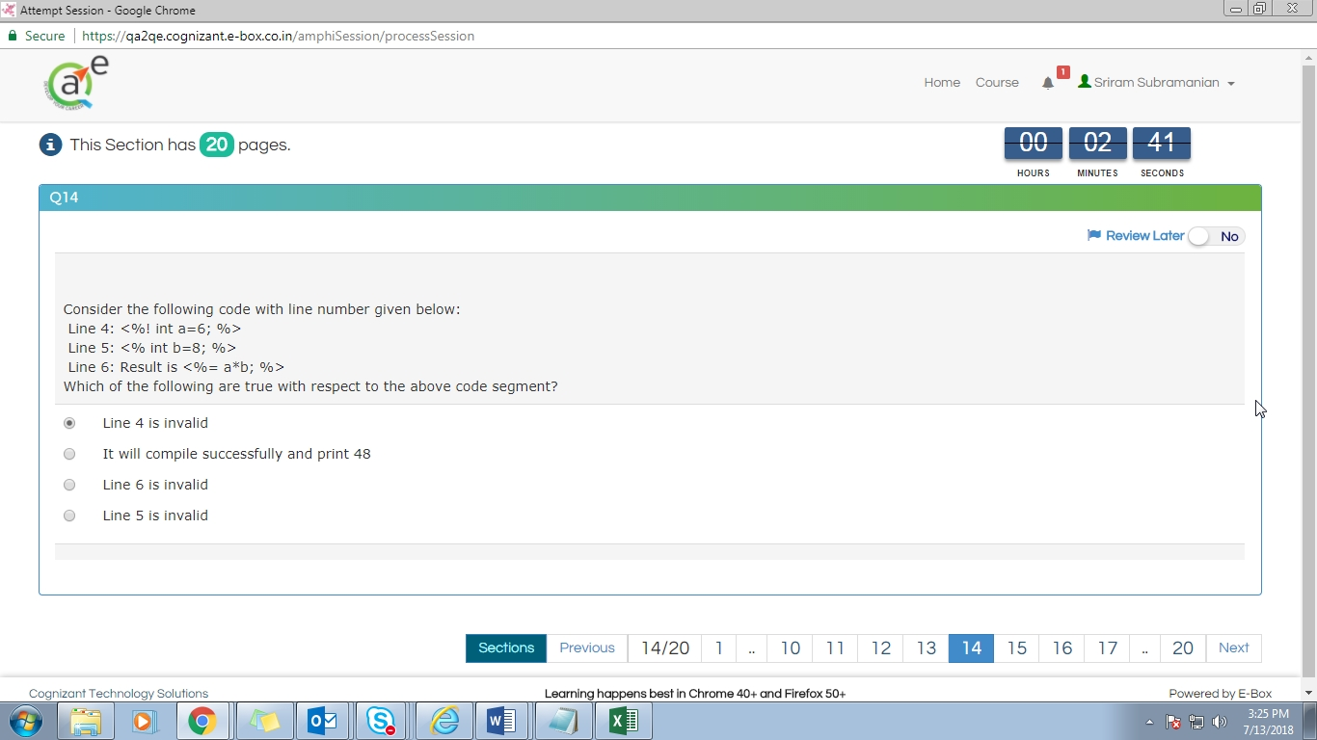Screenshot 29:7/13/2018 15:25:28.788

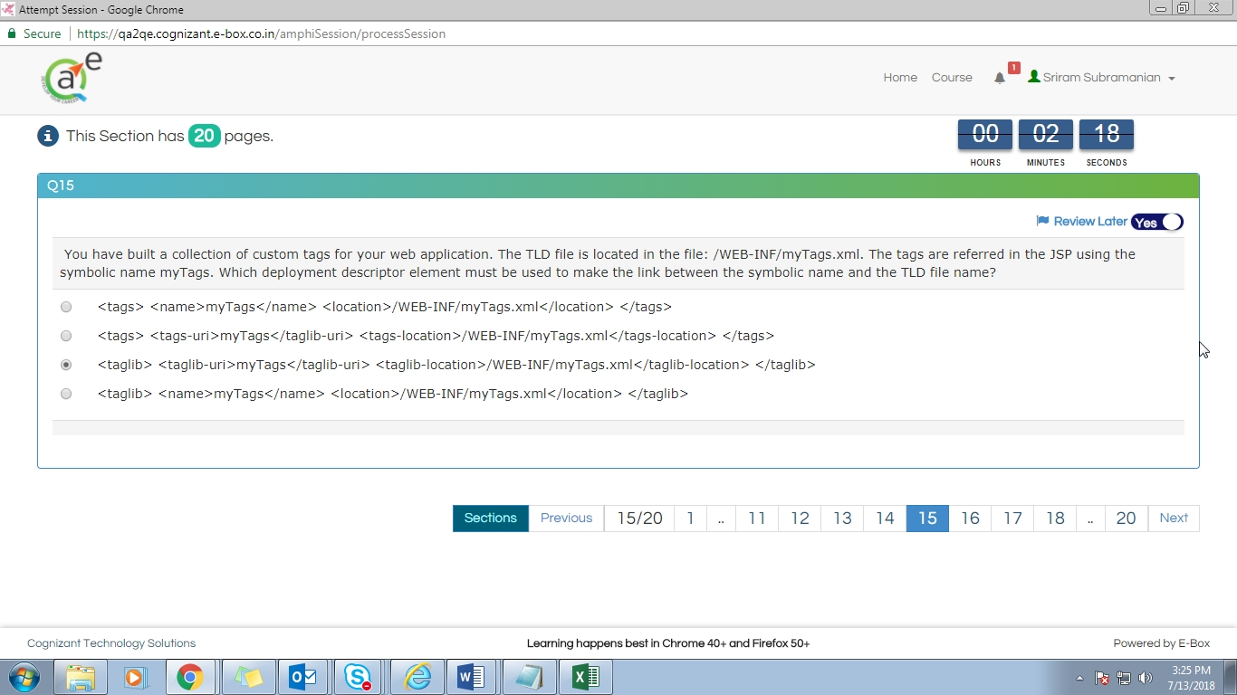Screenshot 30:7/13/2018 15:25:52.066

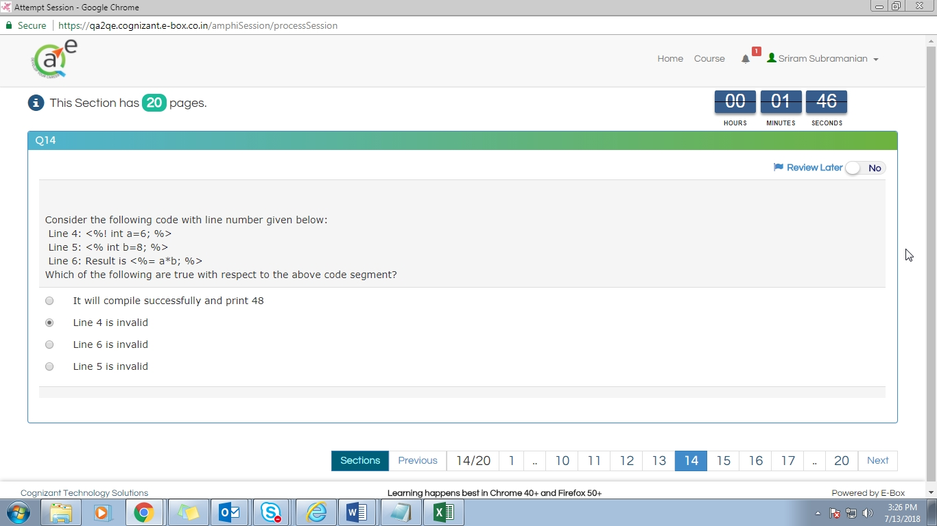Screenshot 33:7/13/2018 15:26:25.234

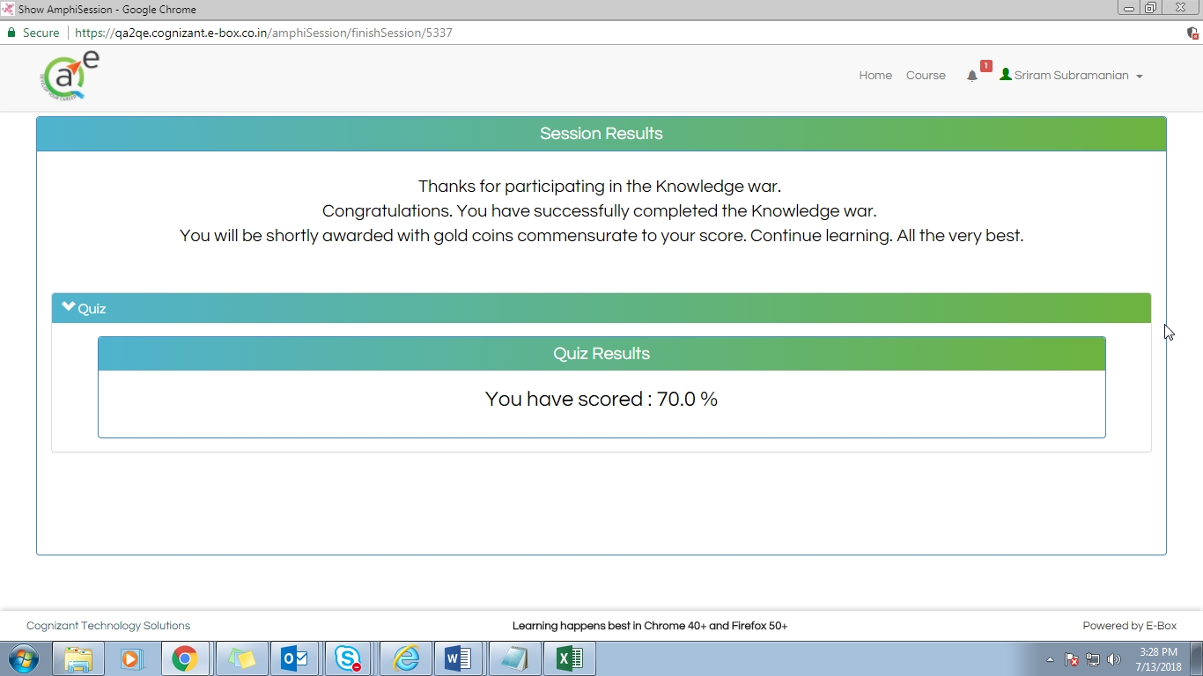Screenshot 36:7/13/2018 15:28:00.496